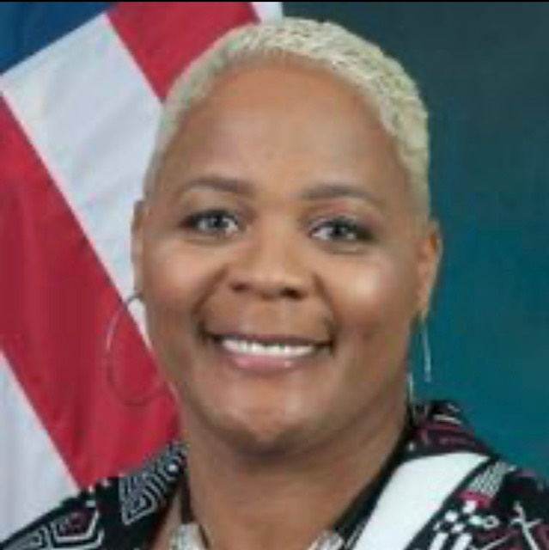
Pamela H. Richards is a newly promoted Supervisory Investigative Research Analyst at the Government Accountability Office (GAO), Forensic, Audit and Investigative Services (FAIS). Mrs. Richards also serves as a committed member on the FAIS' Respect, Equity, Accessibility, Diversity and Inclusion Committee; the Women’s Liaison Group; and the Veterans Affairs Liaison Group. Mrs. Richards has received GAO’s Equal Employment Opportunity, Diversity, and Inclusion Individual and Team Award, and FAIS Managing Directors’ Leadership and Team Award for her grassroots level leadership in diversity and inclusion.

Upon her arrival to GAO, Pamela met with senior level management at GAO an established a presence for the Federal Triangle Chapter of Federally Employed Women (FEW) which is now a part of GAO’s Diversity and Inclusion Strategic Plan and a recognized agency Employee Resource Group. Over the span of her federal career, Mrs. Richards has worked closely with the EEO Office and senior level management, cultivating relationships to assist in developing EEO and compliance policies as well as the equal advancement of women within agencies.

During 2018-2022, Mrs. Richards has served as the DC Metro Regional Manager (RM), with oversight of 26 chapters and chapter presidents; a member of the National Oversight Committee and the Publication and Policy Review Committee of FEW. During her tenure, Pamela created and organized DCMR FEW CARES and provided gas and grocery gift cards to furloughed region members during the government shutdown. Pamela has also collaborated with DCMR FEW partners and feed the homeless, completed a makeover of a Homeless Men’s Shelter and donated over 300 toys for children living in homelessness and poverty. Under her leadership, the DC Metro Region has received the Regional Achievement Award, and numerous National, chapter, and individual awards. Also Pamela held two successful virtual Regional Training Programs and created the Blue Table Talk Leadership Development Series I & II during the pandemic. Due to her demonstrated servant leadership skills, Pamela received FEW’s most prestigious award, the Barbara Boardman Tenant Award and the President’s Award during the first year of her administration. Pamela is also an active member and immediate Past President of the Federal Triangle Chapter. She is an exemplary leader at all three tier levels of FEW.

Mrs. Richards graduated from Albany State University with a B.S. in Criminal Justice, a Masters in Public Administration with a concentration in Human Resource Management and Criminal Justice Administration, and a Masters of Science in Criminal Justice with a concentration in Corrections, all while being a single parent.

Mrs. Richards’s passion is to advocate for the advancement for women and juvenile justice reform. She is originally from Roxboro, North Carolina and the proud wife of Errol M. Richards and mother of one biological son, Jonathan Hall, a writer-editor, and four bonus children, Shenalice, Kamara, Menelik and Kindy. She is a proud member of Gamma Phi Delta Sorority, Inc.

Conflict builds character. Crisis defines it.” “The challenge of leadership is to be strong, but not rude; be kind, but not weak; be bold, but not bully; be thoughtful, but not lazy; be humble, but not timid; be proud, but not arrogant.” “Keep your fears to yourself, but share your courage with others.” Author Unknown

