National Vice President for Compliance.

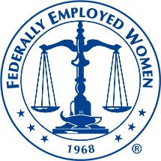

Greetings, I am Dr. Carmela Daniels, current National Bylaws Chair and I am seeking an opportunity to run and serve in the role of the National Vice President for Compliance.
As a Federal Employee I am aware that organizations must work to stay in compliance with its policies and procedures. My vision for this role will be to continue the goals and mission of FEW by ensuring that FEW remains in compliance for the needs of members of FEW. In this role I will continue to make recommendations for the Compliance Program to the Executive Committee. I will continue to be responsible for directing the National FEW Compliance Program. I will maintain and complete current listings of Region and Chapter Compliance committee and chairs. I will work hard and complete all duties as assigned. I have the knowledge, skills and abilities to learn quickly any steps that will be needed to maintain and learn this role. I will make sure that webinars and other guidance on compliance is provided to Regions and Chapters on a continuing basis, including a list of major current regulations, executive orders, and statutes.

