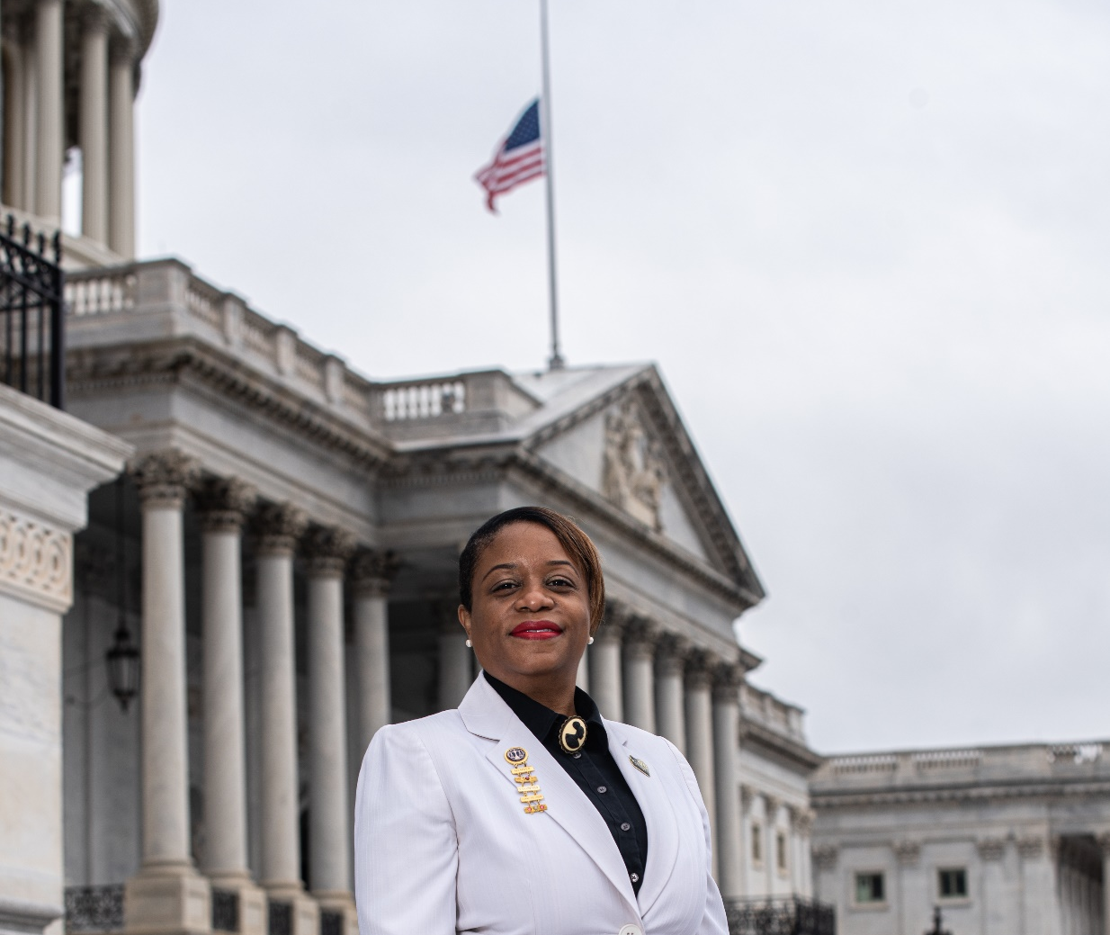

Shabiki E. C. Clarke - Vice President for Congressional Relations
Shabiki E.C. Clarke is a Certified Federal Financial Manager for the Department of Transportation/Federal Aviation Administration (FAA) Headquarters in Washington, D.C. As a career professional, Ms. Clarke’s path has focused on formulation, execution and justification of the federal budget for the FAA Air Traffic Organization (ATO). Currently, as the Financial Advisor, she leads a team of Budget and Finance Analyst to supports the Vice President and Deputy Vice President of the Air Traffic Organization/Technical Operations Directorate.
Shabiki was born in Guyana, South America, and migrated to Maryland in 1982, and now lives in Washington, D.C. She received a BS in Social Science with a Minor in Business from the University of Maryland, Global Campus, with a focus on Advocacy and Civic Engagement. Shabiki developed a love for “serving” others from her father who instilled in her the importance of helping others in need.
She joined the Department of Transportation FEW’s chapter “Women on the Move” in 2018. Ms. Clarke simultaneously served as the Communications and Legislative Chairs for the chapter as well as the DC Metro Region 2018-2020. Ms. Clarke currently serves on the National Board of Directors as the Vice President for Congressional Relations and a member of the FEW-ED Lorna M. Polk Chapter, serving as the Legislative Chair.
In her spare time, she enjoys photography, tennis, and spending time with her family. Her plan is to ENGAGE members across the organization on FEW’s Legislative Agenda for greater grassroots impact.

