SAVE THE DATE!

FEW’s Pacific Northwest Region
Virtual Training Program
“Empowering Women for Success”
RESCHEDULED November 19, 2021
8:30 a.m. – 4:00 p.m. Pacific
Join us for this one-day exceptional virtual training event.
- Hear directly from FEW National President Karen Rainey
- Gain important need-to-know information to plan for a financially stable retirement
- Military Women will acquire knowledge about FEW’s military awards
- Learn about J.E.D.I. (Justice, Equality, Diversity, and Inclusion)
It’s training you do not want to miss!
More information coming soon….
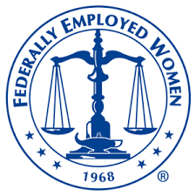 Working for the Advancement of Women in the Government

