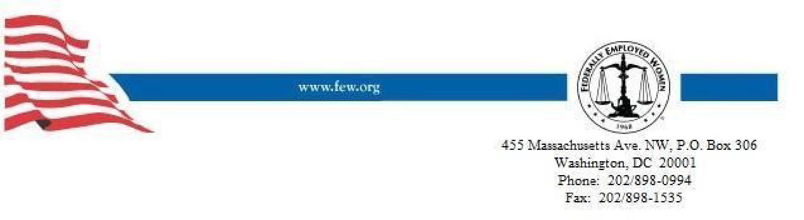
This information may be provided to
FEW membership via government email

FEW Washington Legislative Update
May 1-15, 2021

In Congress

House appropriators are planning to mark-up their federal budget bills for fiscal year 2022 in June, giving lawmakers a few weeks to review their plans and hopes for Department of Defense and Veterans Affairs spending next year.

On Thursday, May 6, during an online event sponsored by the Brookings Institution, House Appropriations Chairwoman Rosa DeLauro, D-Conn., said she expects her panel to mark-up all of the spending bills next month, with the goal of floor passage in July. Senate lawmakers haven’t released a timeline for their budget work yet.

That news, combined with recent comments from Senate Armed Services Committee Chairman Jack Reed, D-R.I., that his panel will mark-up the annual defense authorization bill in July 2021, sets up a hectic two months ahead for defense budget debate on Capitol Hill.

Defense Secretary Lloyd Austin and the military service chiefs are all expected to testify before multiple congressional panels before the end of June 2021.

White House officials in April 2021 unveiled plans for $715 billion in defense spending next fiscal year as part of a larger $1.5 trillion federal budget. Further details on that proposal are expected to be released later this month.

FEW Washington Legislative Update – May 1-15, 2021
Tier I

Pregnancy Paid Leave:
The House is set to vote this week on HR-1065, which would expand workplace protections for pregnancy, childbirth or related medical conditions for federal employees along with many employees of private sector companies.
The bill would require employers including federal agencies to make a “reasonable accommodation” parallel to what is required for employees with disabling conditions under the Americans with Disabilities Act (ADA) unless that would impose an “undue hardship” on the employer. The Equal Employment Opportunity Commission (EEOC) would define such accommodations, which under the ADA can include making existing facilities used by employees readily accessible, job restructuring, part-time or modified work schedules, reassignment, and more.
The bill would make it unlawful to: deny employment opportunities to current employees or job applicants based on the need of the entity to make such; require employees to take paid or unpaid leave if another reasonable accommodation can be provided; or take adverse action in retaliation for an employee requesting or using such accommodations.
For federal employees, remedies for violations could include the EEOC complaint process or an appeal to the Merit Systems Protection Board (MSPB) and in certain circumstances the right to sue in federal court.
Most federal employees already are covered by the 1978 Pregnancy Discrimination Act, which provides some similar protections.
Sourced from FedWeek.

FEW Washington Legislative Update – May 1-15, 2021
Tier II

COVID Vaccination Paid Leave:
Federal agencies “should grant” employees who suffer adverse side-effects of a Coronavirus inoculation up to two workdays of administrative leave, according to a new posting on the www.saferfederalworkforce.gov site.
That applies for each dose of vaccine (two of the three vaccines require two doses, the other just one) and “if an employee requests more than 2 workdays to recover, the agency may make a determination to grant emergency paid leave as created by the American Rescue Plan Act—if available—or other appropriate leave (e.g. sick leave) at that point,” it says.
That is in addition to the four hours of leave previously authorized for receiving each dose of vaccine, an amount the guidance terms a minimum while adding that, “if an employee needs to spend less time getting the vaccine, only the needed amount of administrative leave should be granted.”
Administrative leave, also commonly called excused absence, is paid time off without charge to any other form of leave that agencies can grant at their discretion. Separately, the American Rescue Plan law created a “emergency paid leave” fund from which agencies can draw to provide paid time off for federal employees unable to work due to certain pandemic-related reasons.
Meanwhile, Department of Defense (DoD) has issued a memo for its own workforce setting similar policies while specifying that the amount of time allowed should only be enough to cover time spent traveling to and from the vaccination provider, the time spent there, and a “reasonable amount of recovery time.” Supervisors may grant additional time in “extenuating circumstances.”
“Employees may not be authorized to perform overtime work for purposes of obtaining a vaccination outside their scheduled tour of duty,” it adds, and compensatory time is not to be granted for those who are vaccinated outside of their working hours. Administrative leave is not available to take a family member to receive a vaccination.
Sourced from FEDWeek.

FEW Washington Legislative Update – May 1-15, 2021
Tier III

Economic Recovery and Women:
The road to full economic recovery from the pandemic may be steeper than anticipated.
U.S. employers added 266,000 jobs last month, the Labor Department reported Friday, May 14, 2021add the calendar date. That's far fewer than the nearly 1 million analysts expected given other recent signs of recovery: business reopening, consumer spending increasing, and new unemployment claims falling.
"Our economy is definitely recovering, but there are still millions of people in economic pain," Labor Secretary Marty Walsh said in an interview with All Things Considered. "We still have issues around child care. We still have issues around vaccines. We still have issues around people getting the virus. So, we still have a ways to go here."
Child care problems and many kids still learning from home in part led millions of women to leave the workforce during the pandemic. Walsh said that's a big concern for the Biden administration. The president's proposed American Families Plan includes $225 billion for child care.
"We need to make sure if we're going to have a strong recovery — a strong, equitable recovery — we need to get women back into the workforce," Walsh said.
Following are highlights of the interview, edited for length and clarity.
On April's weaker-than-expected jobs numbers
Under normal circumstances, adding 266,000 jobs to the economy is a good number, but obviously we're not in normal times. We're definitely seeing the economy go in the right direction, but we still have a steep hill to climb. If you look at over the last three months, however, we've averaged over 500,000 jobs on average over the last three months, so we've added 1.5 million jobs. That shows good gain there as compared to the previous three months.
On what's holding employers back from adding more jobs
There's no question about it. People are still recovering from the pandemic. There are still concerns as far as businesses. ... There's a bunch of bright sides of this report, but one of them was that we saw the leisure and hospitality industry grew immensely, and that includes restaurants. We also saw more people in the month of April looking for employment than the previous months. But we're still in the midst of a pandemic.
On whether he's concerned that this could be a jobless recovery
No, I don't believe that. People are going to go back to work and people are going to get back to work. ... The president has made it very clear with the American Rescue Plan about strengthening and getting this economy moving forward. ... We are definitely moving in the right direction. Hospitality is opening in the different areas. We saw an increase in retail as well — in-person retail. But there's still lots of lots of people still working from home or looking for employment.
On whether unemployment benefits discourage people from looking for work
You know, I don't like when people talk about generous unemployment benefits because unemployment benefits are there to help people in very difficult, bad times. And many, many Americans have gone through very difficult, bad times for the last year. I think what we're seeing is that there are still major barriers to getting people back into the workforce ... lack of child care, also schools, you know, hybrid learning — in-person learning and online learning. People worried about the virus, people [worried] about getting vaccinated, people that are caretakers. So, there's still barriers there. I'm not saying that's the whole excuse. ... People want to be back in the workplace. People want to be back working. ... With unemployment benefits, you don't get health care. You don't build your pension up. You don't build all of those programs that you need to move forward.
On helping women get back into the workforce
A couple weeks ago, the president and the White House released $30 billion ... to deal with that specific issue of child care. And it's about making investments in the child care facilities around our country. And that money is getting out around the country right now. So that's one aspect. ... We need to make sure if we're going to have a strong recovery — a strong, equitable recovery — we need to get women back into the workforce.
And that's something that the president is focused on. That's something that I'm focused on here at the Department of Labor, as well as our unemployment numbers in the Black community. Today it is 9.7 percent. So, our communities of color have higher unemployment rates than their white counterparts. ... We've always seen that discrepancy going back generations. But we have to be really intentional about investments that we're making to make sure that as we recover from the pandemic, it's an equitable recovery for all — for women and for people of color.
Sourced from NPR.
FEW receives information from the following sources and contacts: Federal News Network, GovernmentExecutive, NPR, MilitaryTimes.

