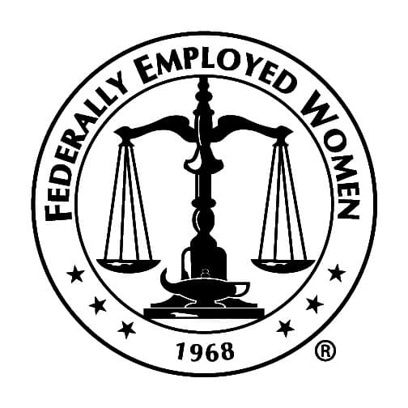

FEW “SCHEDULE F” ISSUE PAPER
Washington Premier Group
November 5, 2020

At Issue:

President Trump recently signed an executive order creating a new classification of “policy-making” federal employees that could strip swaths of the federal workforce of civil service protections just before the next session of Congress.

The order would create a new Schedule F within the excepted service of the federal government, to be composed of “employees in confidential, policy-determining, policy-making, or policy-advocating positions,” and instructs agency heads to determine which current employees fit this definition and move them—whether they are members of the competitive service or other schedules within the excepted service—into this new classification.

Federal regulations stating that employees hired into the competitive service retain that status even if their position is moved to the excepted service will not apply to Schedule F transfers.

Positions in the new Schedule F would effectively constitute at-will employment, without any of the protections against adverse personnel actions that most federal workers currently enjoy, although individual agencies are tasked with establishing “rules to prohibit the same personnel practices prohibited” by Title 5 of the U.S. Code. The order also instructs the Federal Labor Relations Authority to examine whether Schedule F employees should be removed from their bargaining units, a move that would bar them from being represented by federal employee unions.

“Except as required by statute, the civil service rules and regulations shall not apply to removals from positions listed in Schedules A, C, D, E, or F, or from positions excepted from the competitive service by statute,” the order states.

The order sets a swift timetable for implementation: Agencies have 90 days to conduct a “preliminary” review of their workforces to determine who should be moved into the new employee classification—a deadline that coincides with Jan. 19, the day before the next presidential inauguration.

The White House argued that the executive order is a necessary reform to ensure that federal officials can more efficiently remove “poor performers.” “Effective performance management of employees in confidential, policy-determining, policy-making or policy-advocating positions is of the utmost importance,” the order states. “Unfortunately, the government’s current performance management is inadequate, as recognized by federal workers themselves.

For instance, the 2016 Merit Principles Survey reveals that less than a quarter of federal employees believe their agency addresses poor performers effectively.”

But federal employee groups and government observers described the executive order as a “stunning” attempt to politicize the civil service and undermine more than a century of laws aimed at preventing corruption and cronyism in the federal government.

The Law:

The [1883] Pendleton Act and subsequent civil service laws was enacted to create a career civil service with expertise that is both accountable to elected officials but also a repository of expertise in government. (Under a fresh wave of reforms in 1978, the commission was dissolved; its functions were split among the Office of Personnel Management, the Merit Systems Protection Board, the Equal Employment Opportunity Commission, the Federal Labor Relations Authority, and the Office of Special Counsel, which, among other duties, offers federal employees a secure channel to file whistleblower complaints.)

As mentioned, the argument here is that anyone involved in policymaking can be swept into this new classification, and once included they are subject to political review and dismissal for any reason.

The overarching concern is that the order could be far reaching in scope. Not only would high profile employees who publicly disagree with a president be targeted for removal, but lower level employees tasked with collecting the data and evidence underlying much of what the federal government does could be affected.

Rep. Gerry Connolly, D-Va., who serves as chairman of the House Oversight and Reform Committee's subcommittee on government operations, blasted the administration's efforts to remove workers' civil service protections.

TALKING POINTS AGAINST CREATION OF SCHEDULE F

- The President’s executive order attempts to bypass the laws of this country to embed an additional political corps into the federal workforce. In our system of government, political appointees serve at the pleasure of the President and owe fidelity to the President they serve under. Career civil servants and uniformed service members take the oath of office, not to the President, but to the Constitution.

- This Executive Order will further the message that career federal workers are corrupt and not dedicated to serving all Americans equally. This philosophy plays directly into the hands of our adversaries who seek to encourage civil unrest and undermine the foundations of our democracy.

- American taxpayers fund thousands of political appointees in the executive branch, through Presidential Appointments, requiring the advice and consent of the Senate and Schedule C political appointments. Deliberate actions by Congress and the Supreme Court have differentiated these partisan positions from the career federal workforce which serves not based on political allegiance but based on merit.

- Civil servants do not consider partisan politics when executing their continuously vital missions, including conducting vital health research, overseeing economic relief packages, protecting our national security and elected leaders, and delivering essential emergency aid. These missions require a merit- based test, not a loyalty test.

- With this order, there is no longer an independent civil service.

